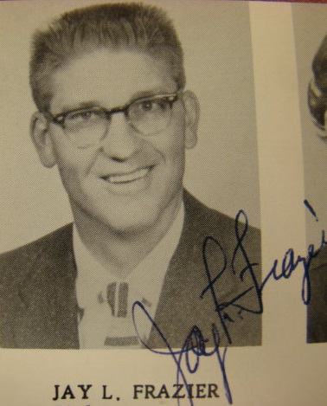
The Jay Frazier Years
1957-1983 (26 Seasons)

Overall Record: 409-160 (0.719)

Situation | Wins | Losses | Winning Pct.
Home Record | 229 | 62 | 0.787
Away Record | 180 | 98 | 0.647
League Record | 216 | 100 | 0.684
Non-League Record | 193 | 60 | 0.763
Invitational Record | 38 | 19 | 0.667
Sub-State Record | 36 | 14 | 0.720
State Record | 21 | 9 | 0.700

League Titles: 10

League Runner-Up Finishes: 5

Mac Invitational Titles: 4

State Appearances: 12

State Championships: 3

State Runner-Up: 4

State Final Four: 9

Revised: 4/26/2020

